# 

# Social Network Analysis

## Analysing Patrick Holm’s Ego Network

44808097

Data Collection Process

Data was collected through the Chrome extension Lost Circles, this tool collected data that pertained to friends and mutual friends within a Facebook Network.

Fig 1: Lost Circles Visualisation of Facebook Network

Defining Factors of the Data

* Nodes: 581
* Edges: 50138
* Diameter: 7
* Average path length: 2.39

Original Data in Gephi

The data shown below demonstrates the interconnected nature of the ego network, using the Force Atlas 2 function. It demonstrates that while there is one distinct group, most of the nodes relate heavily to one another.

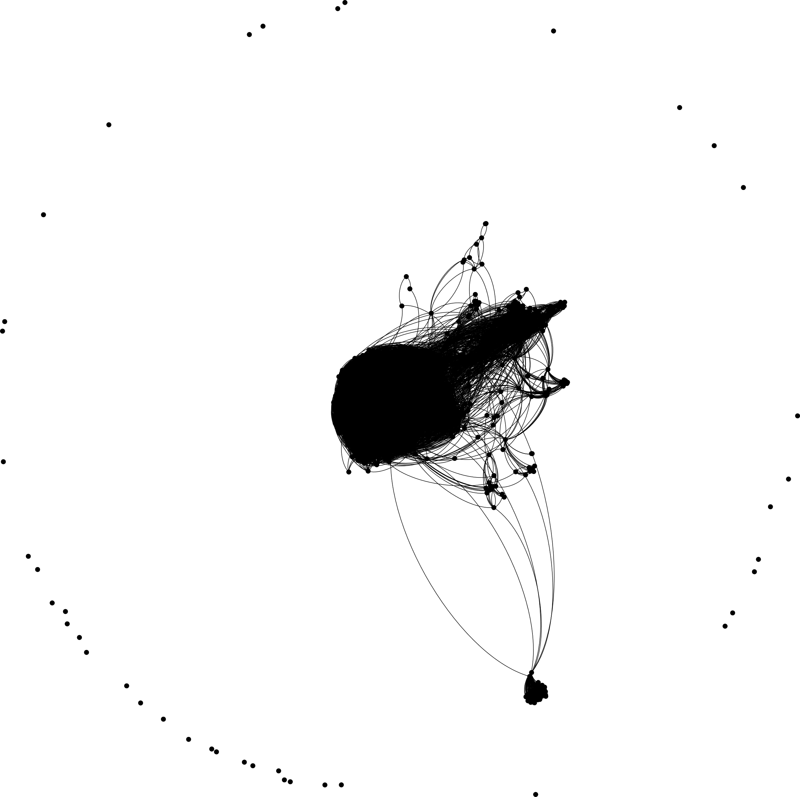

Fig 2: Data seperated through the use of Force Atlas function alone.

Simplifying the Data

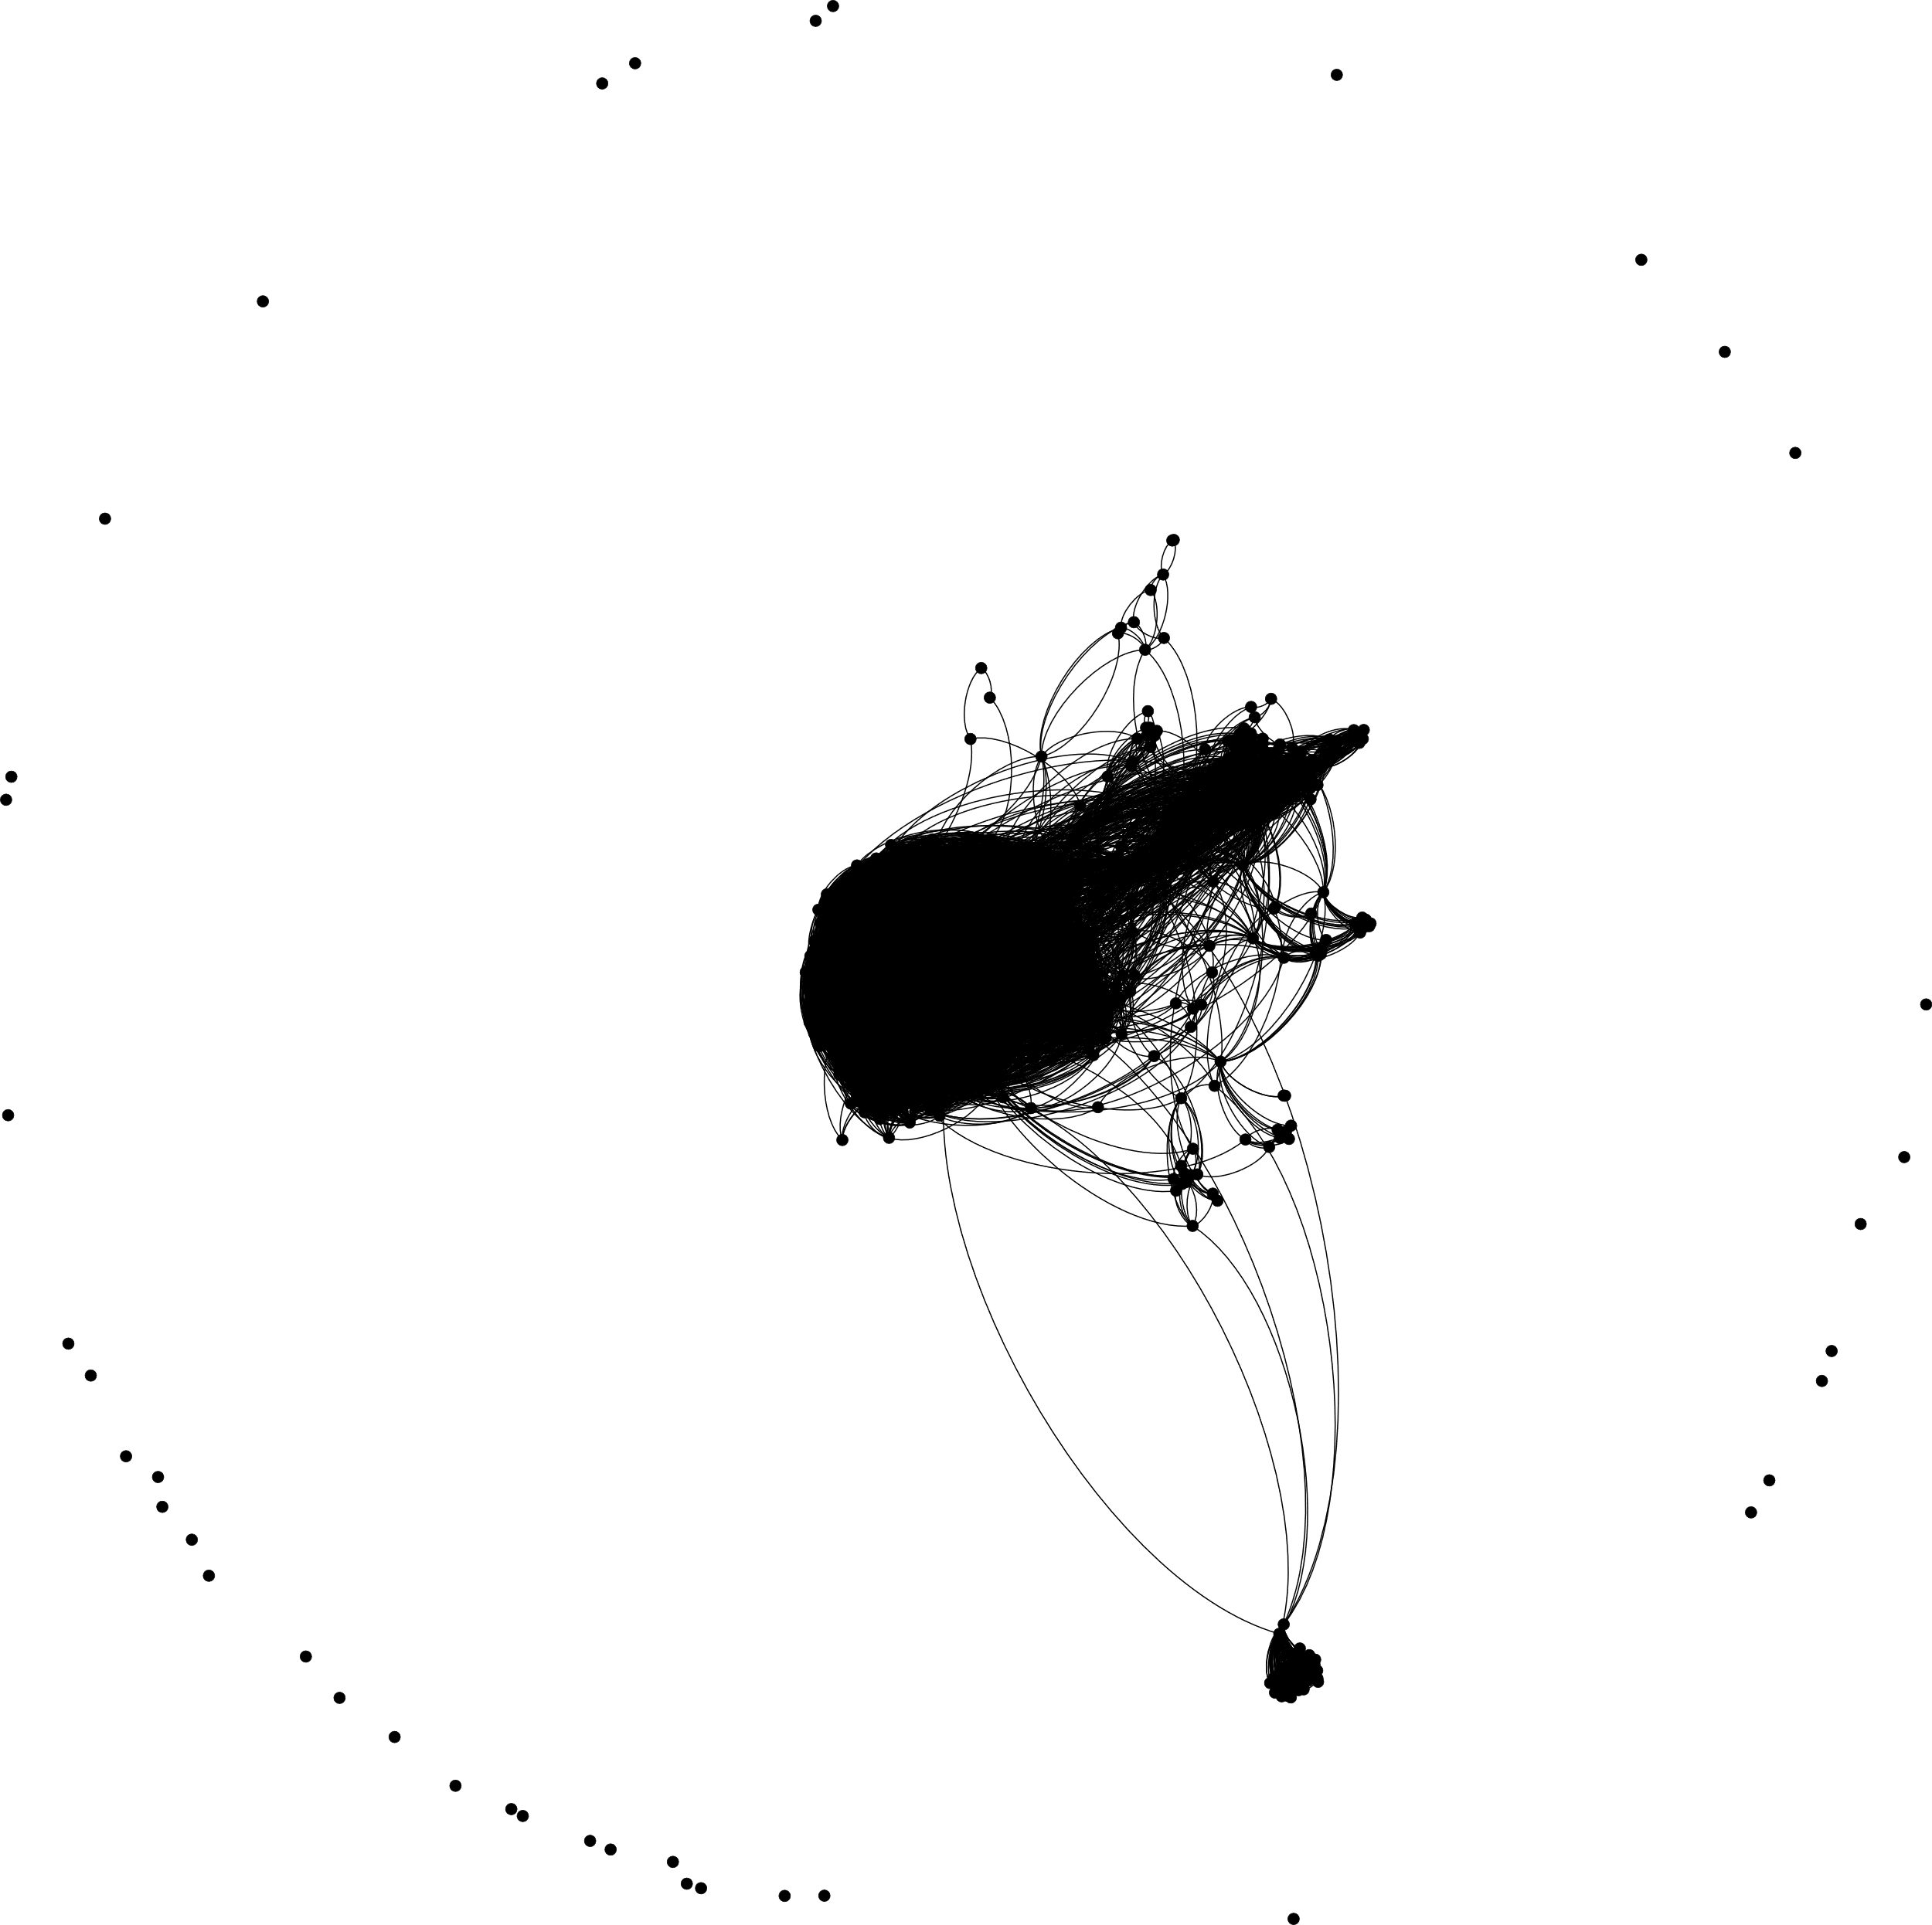

The Data within this Modularity Class skews the rest of the data, in that, each of these nodes is perceived to be more important because they are linked to so many other nodes. An example of how this community is so much larger can be seen in the Modularity graph below. Circled in Red.

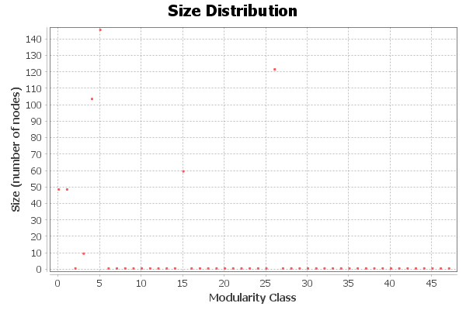

Fig 3: Strongly Connected Community

This irregular group is a High School community where everyone added each other on Facebook thus explaining the interconnected group. To make the analysis of the data balanced this group was removed. Some analysis will be conducted on the group at a later stage in this report.

Analysis of the Data

Modularity Applied to Data

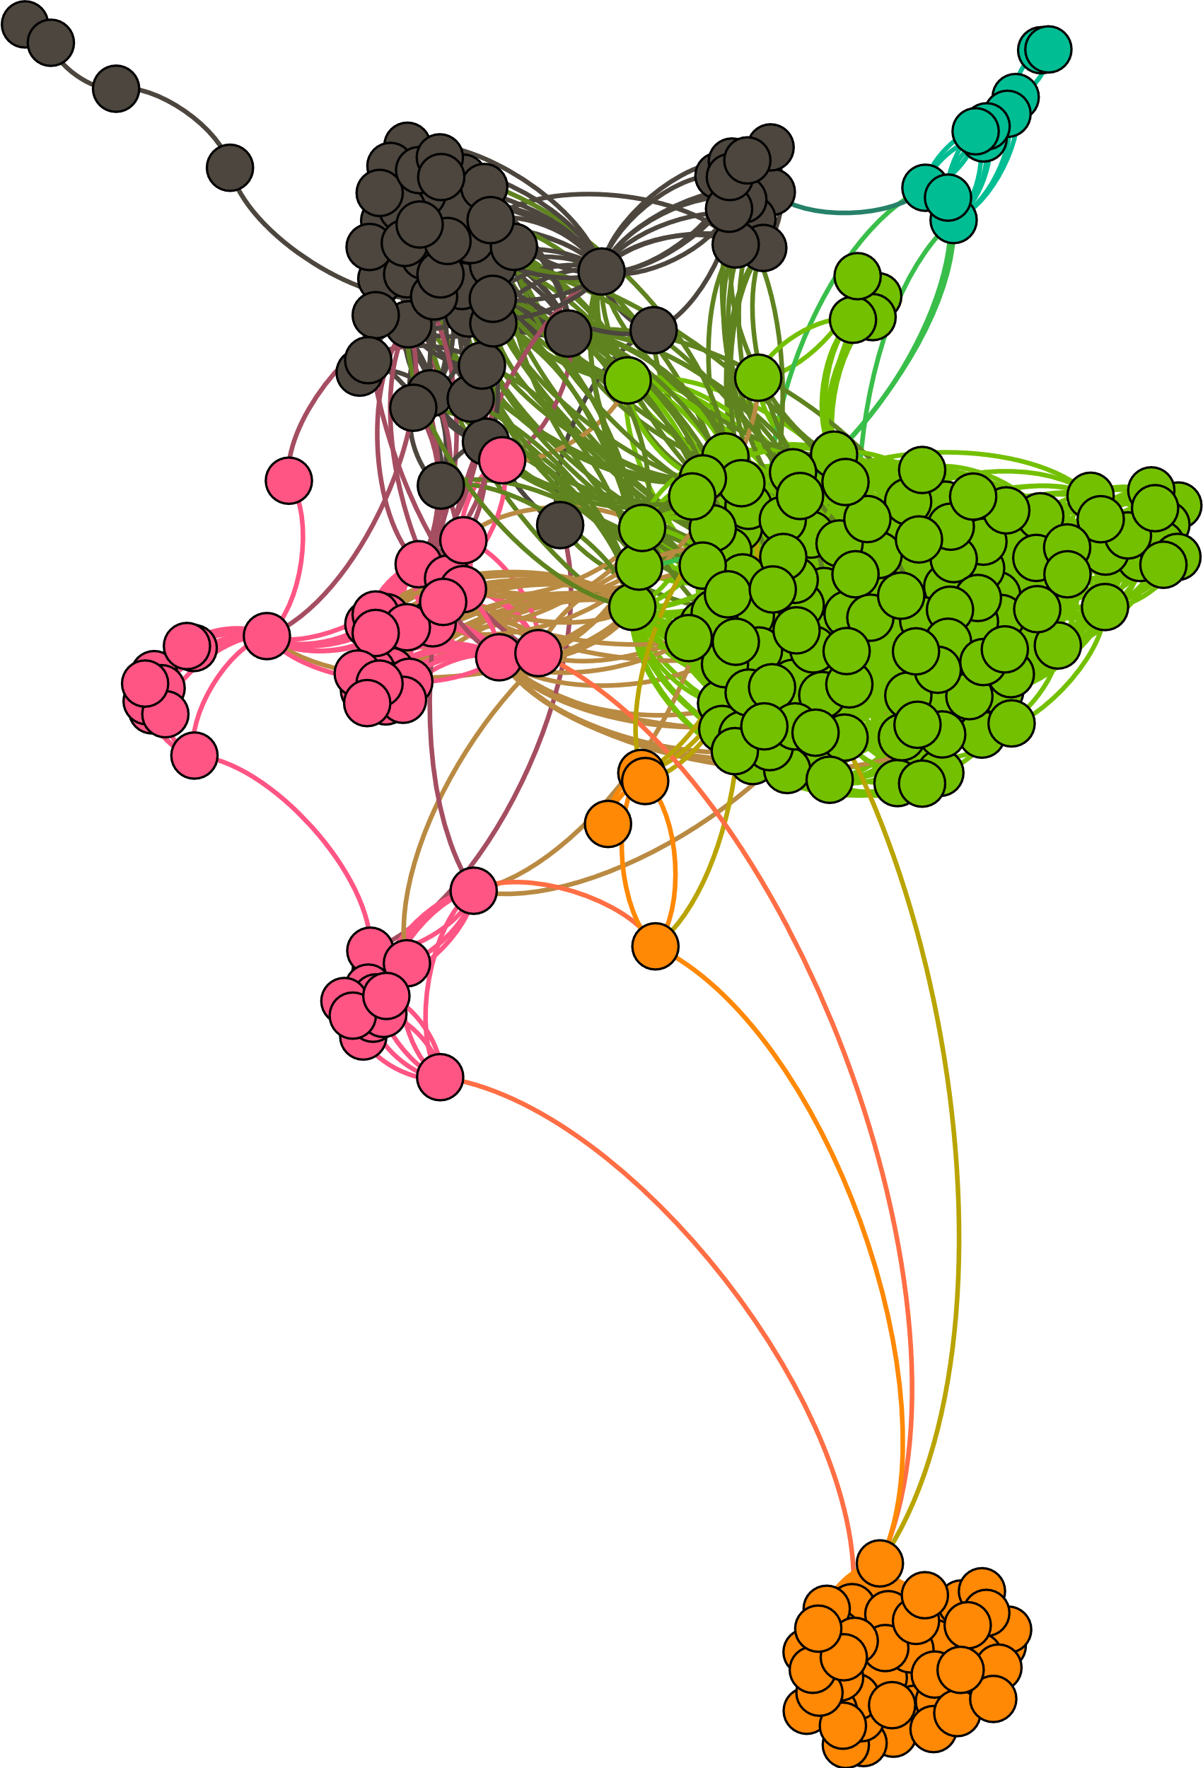

Modularity shows 5 distinct groups present. These groups mostly match with real world expectations.

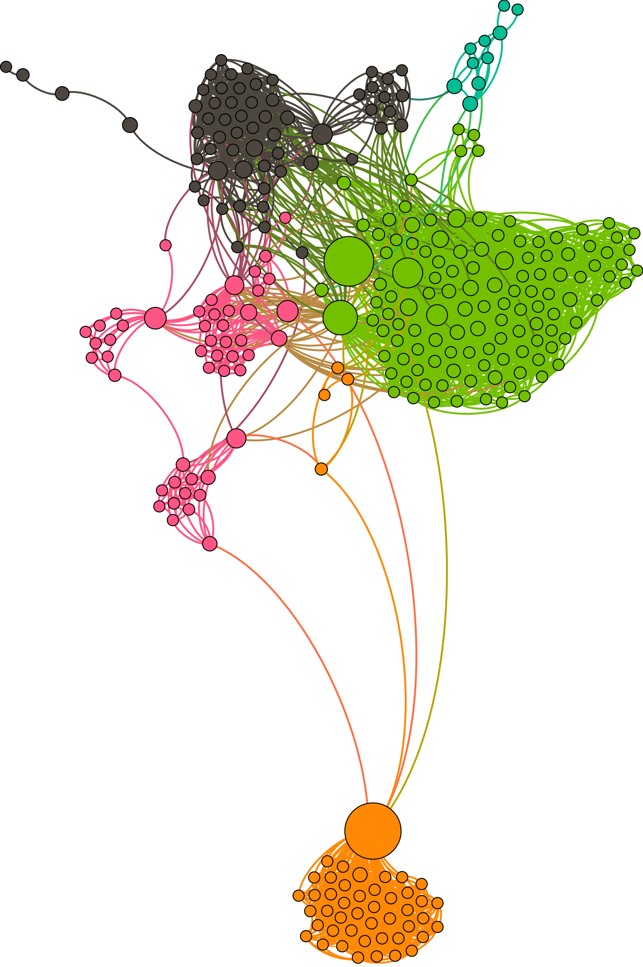Modularity and Betweenness Centrality Factors Applied to Data

This reveals several important nodes that connect groups together, and mostly matches with reality. However, the modularity is a bit too constrained in the makeup of the groups.

Modularity and Degree

Degree demonstrates the importance of nodes based on the number of nodes it is connected to.

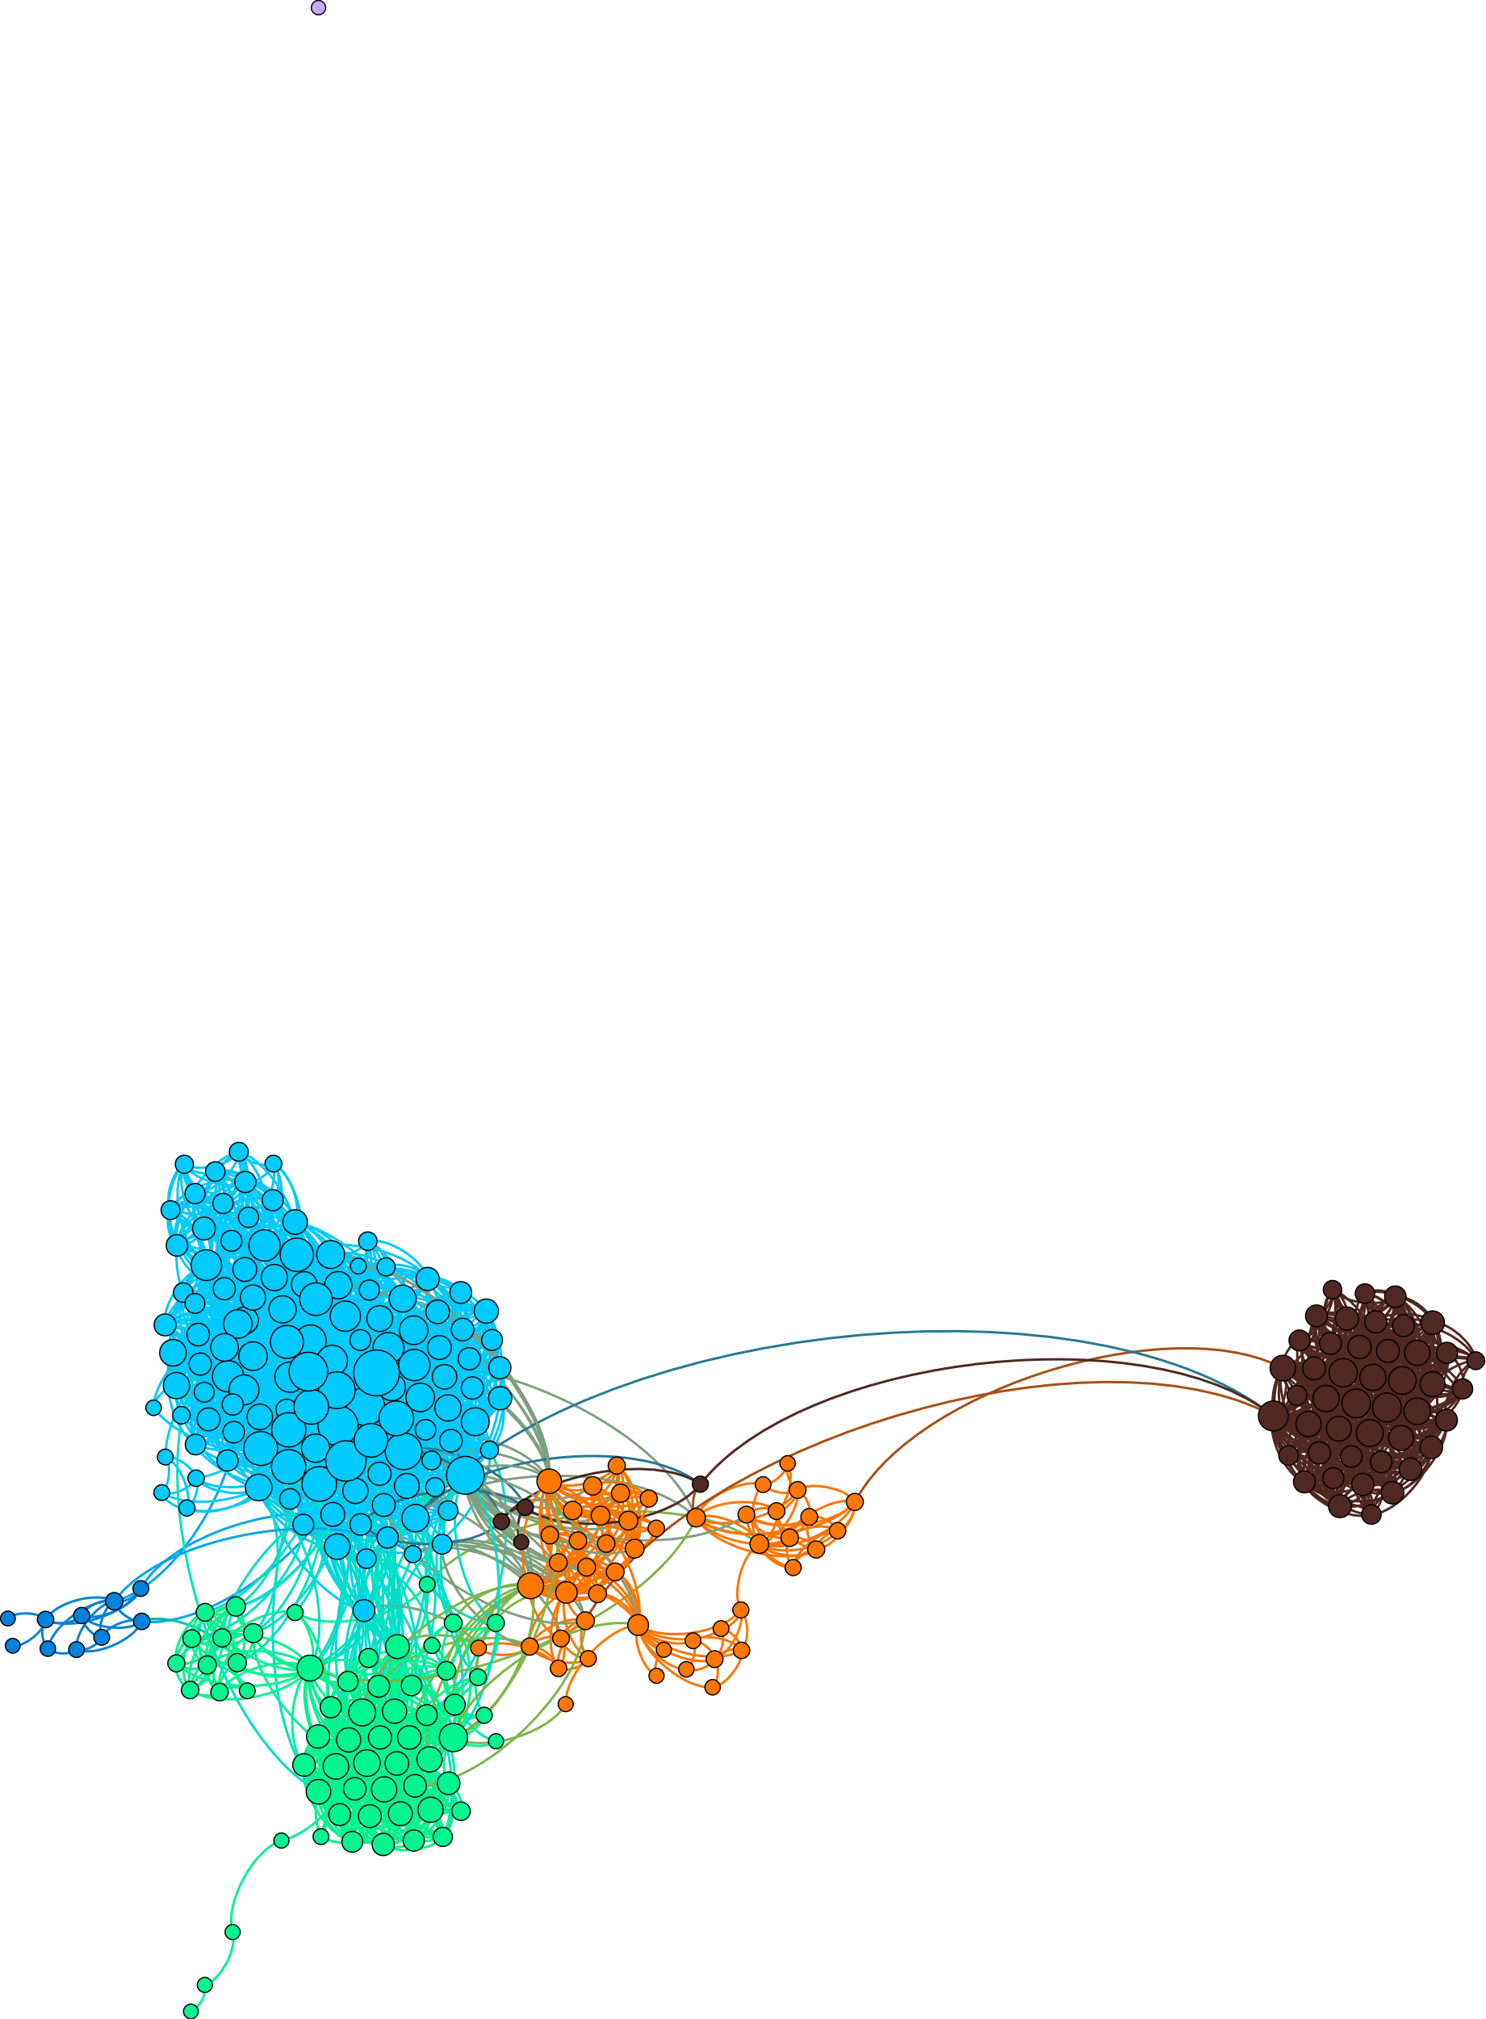

Modularity and Betweenness Centrality Configured for smaller communities

This example shows the different communities within each larger group, the circled community is representative of a large baseball community and the different clubs therein.

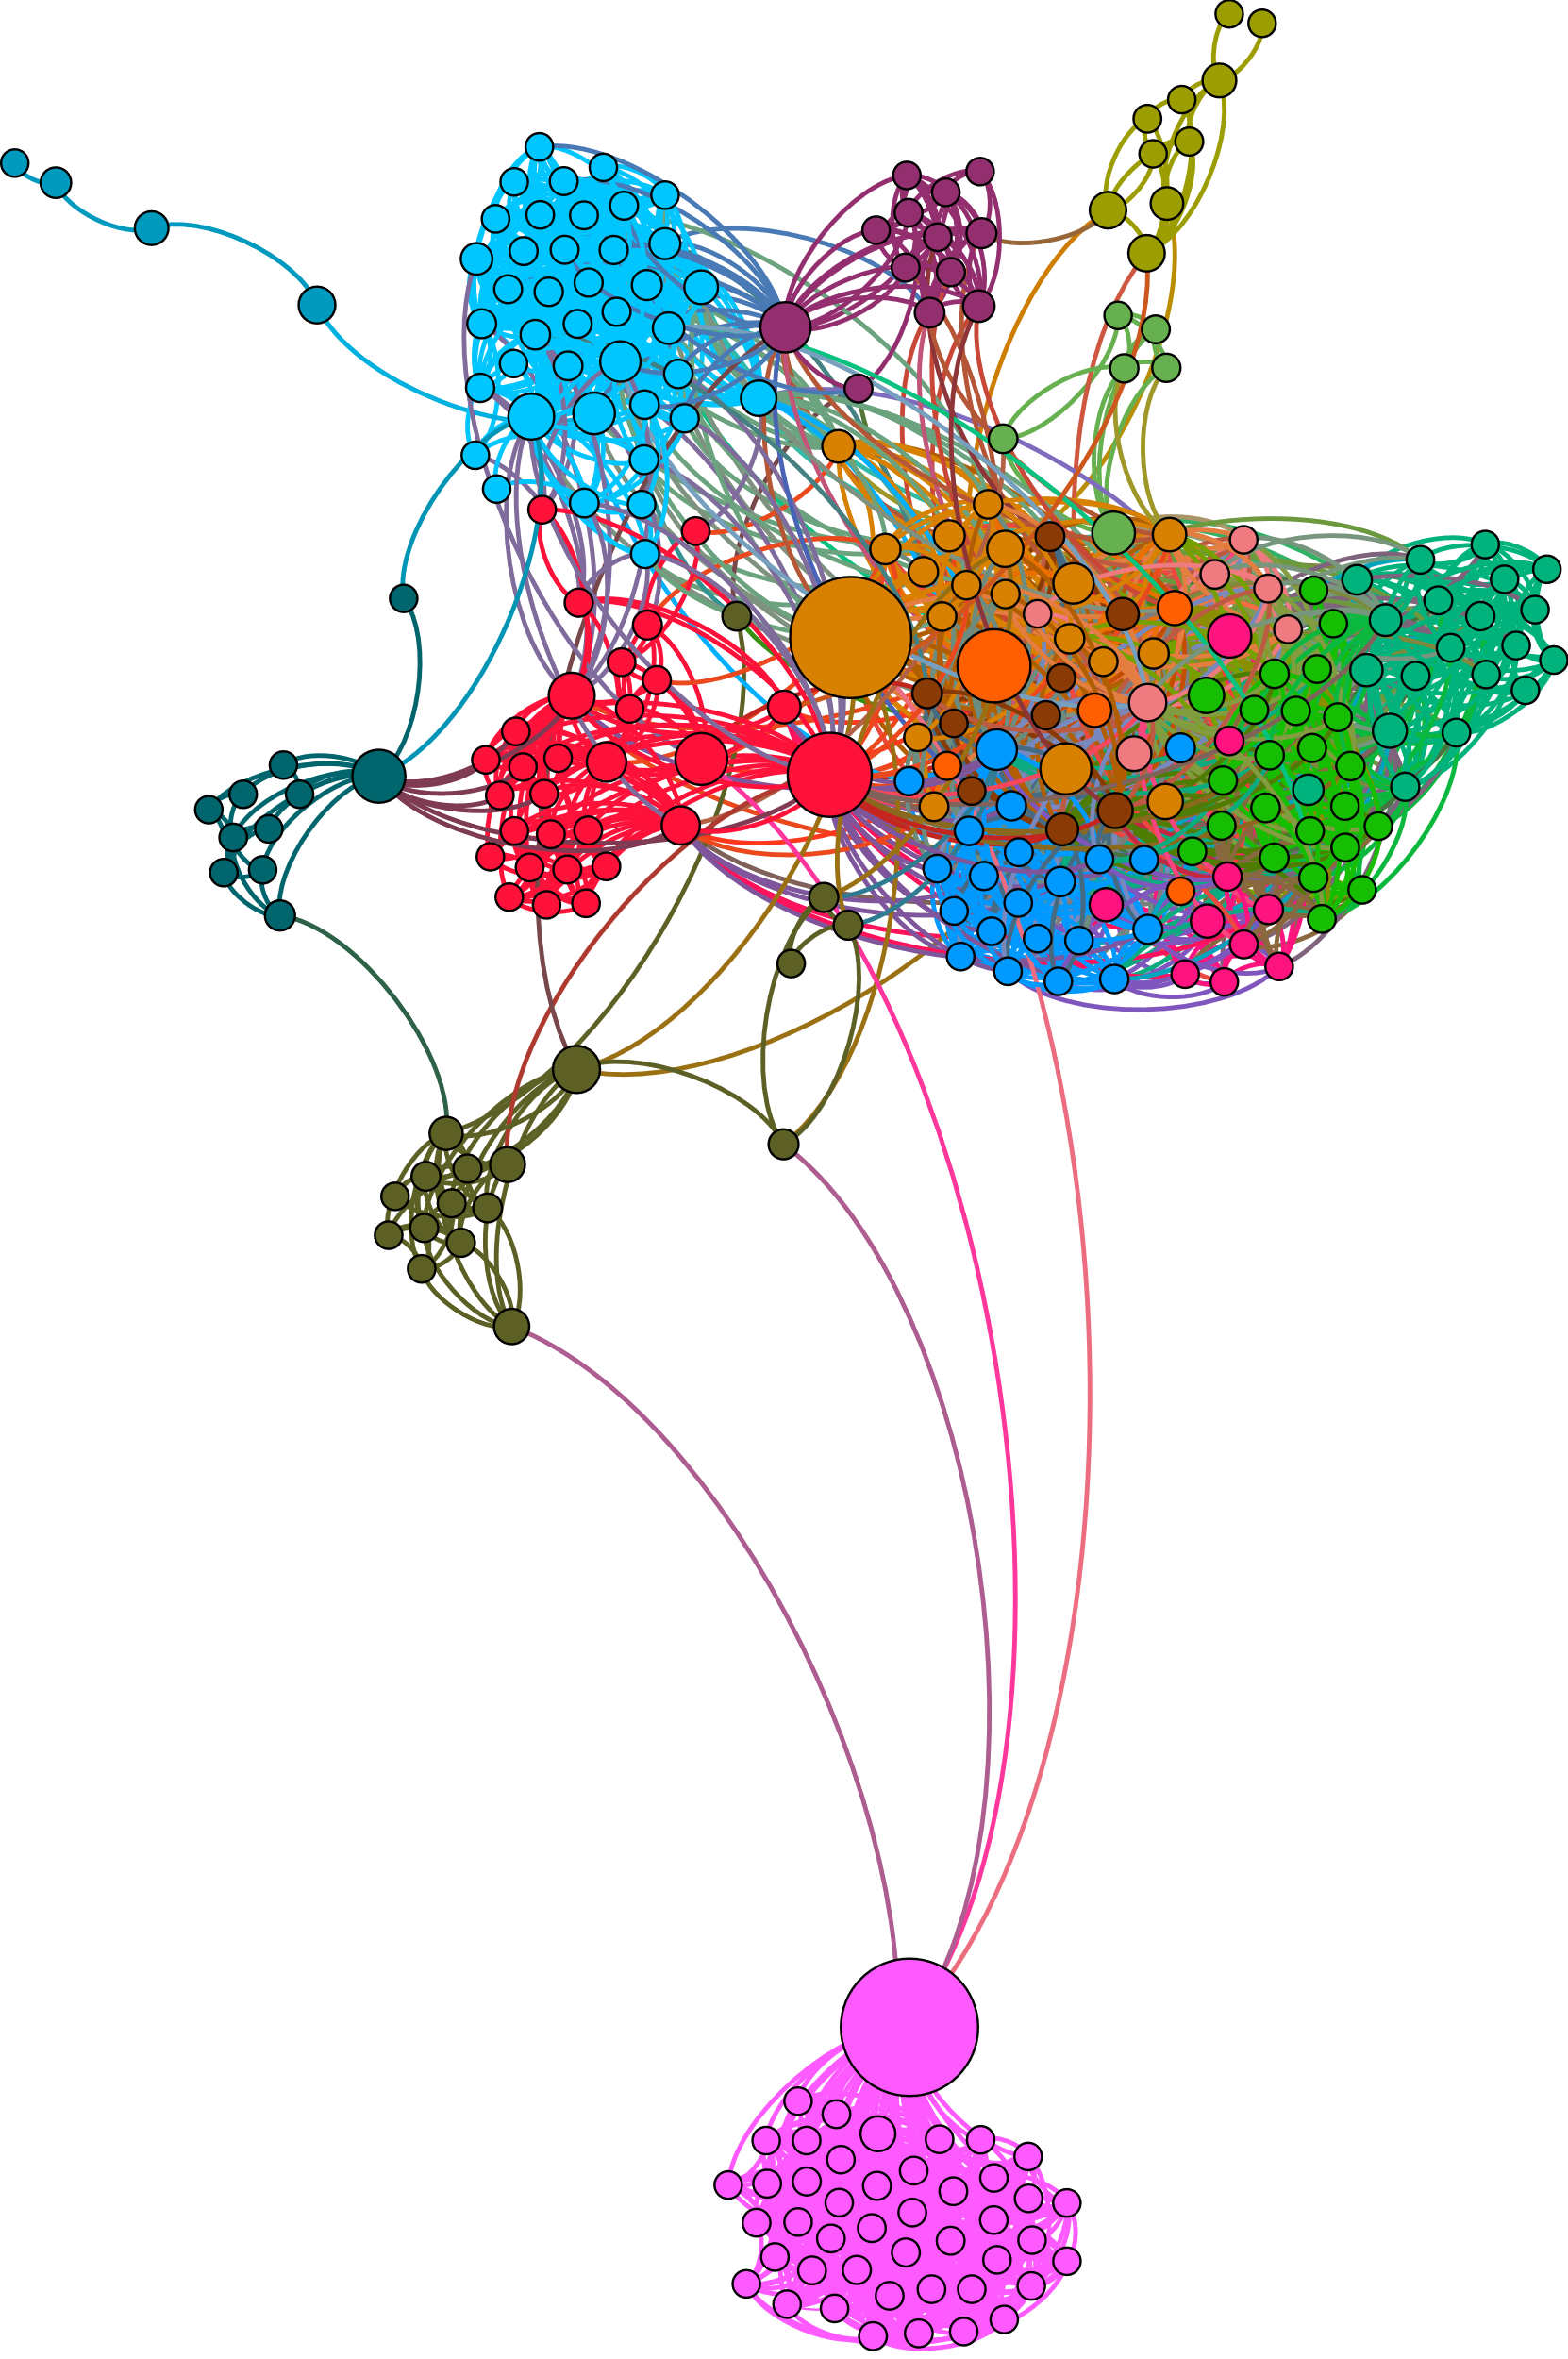

The High School Community

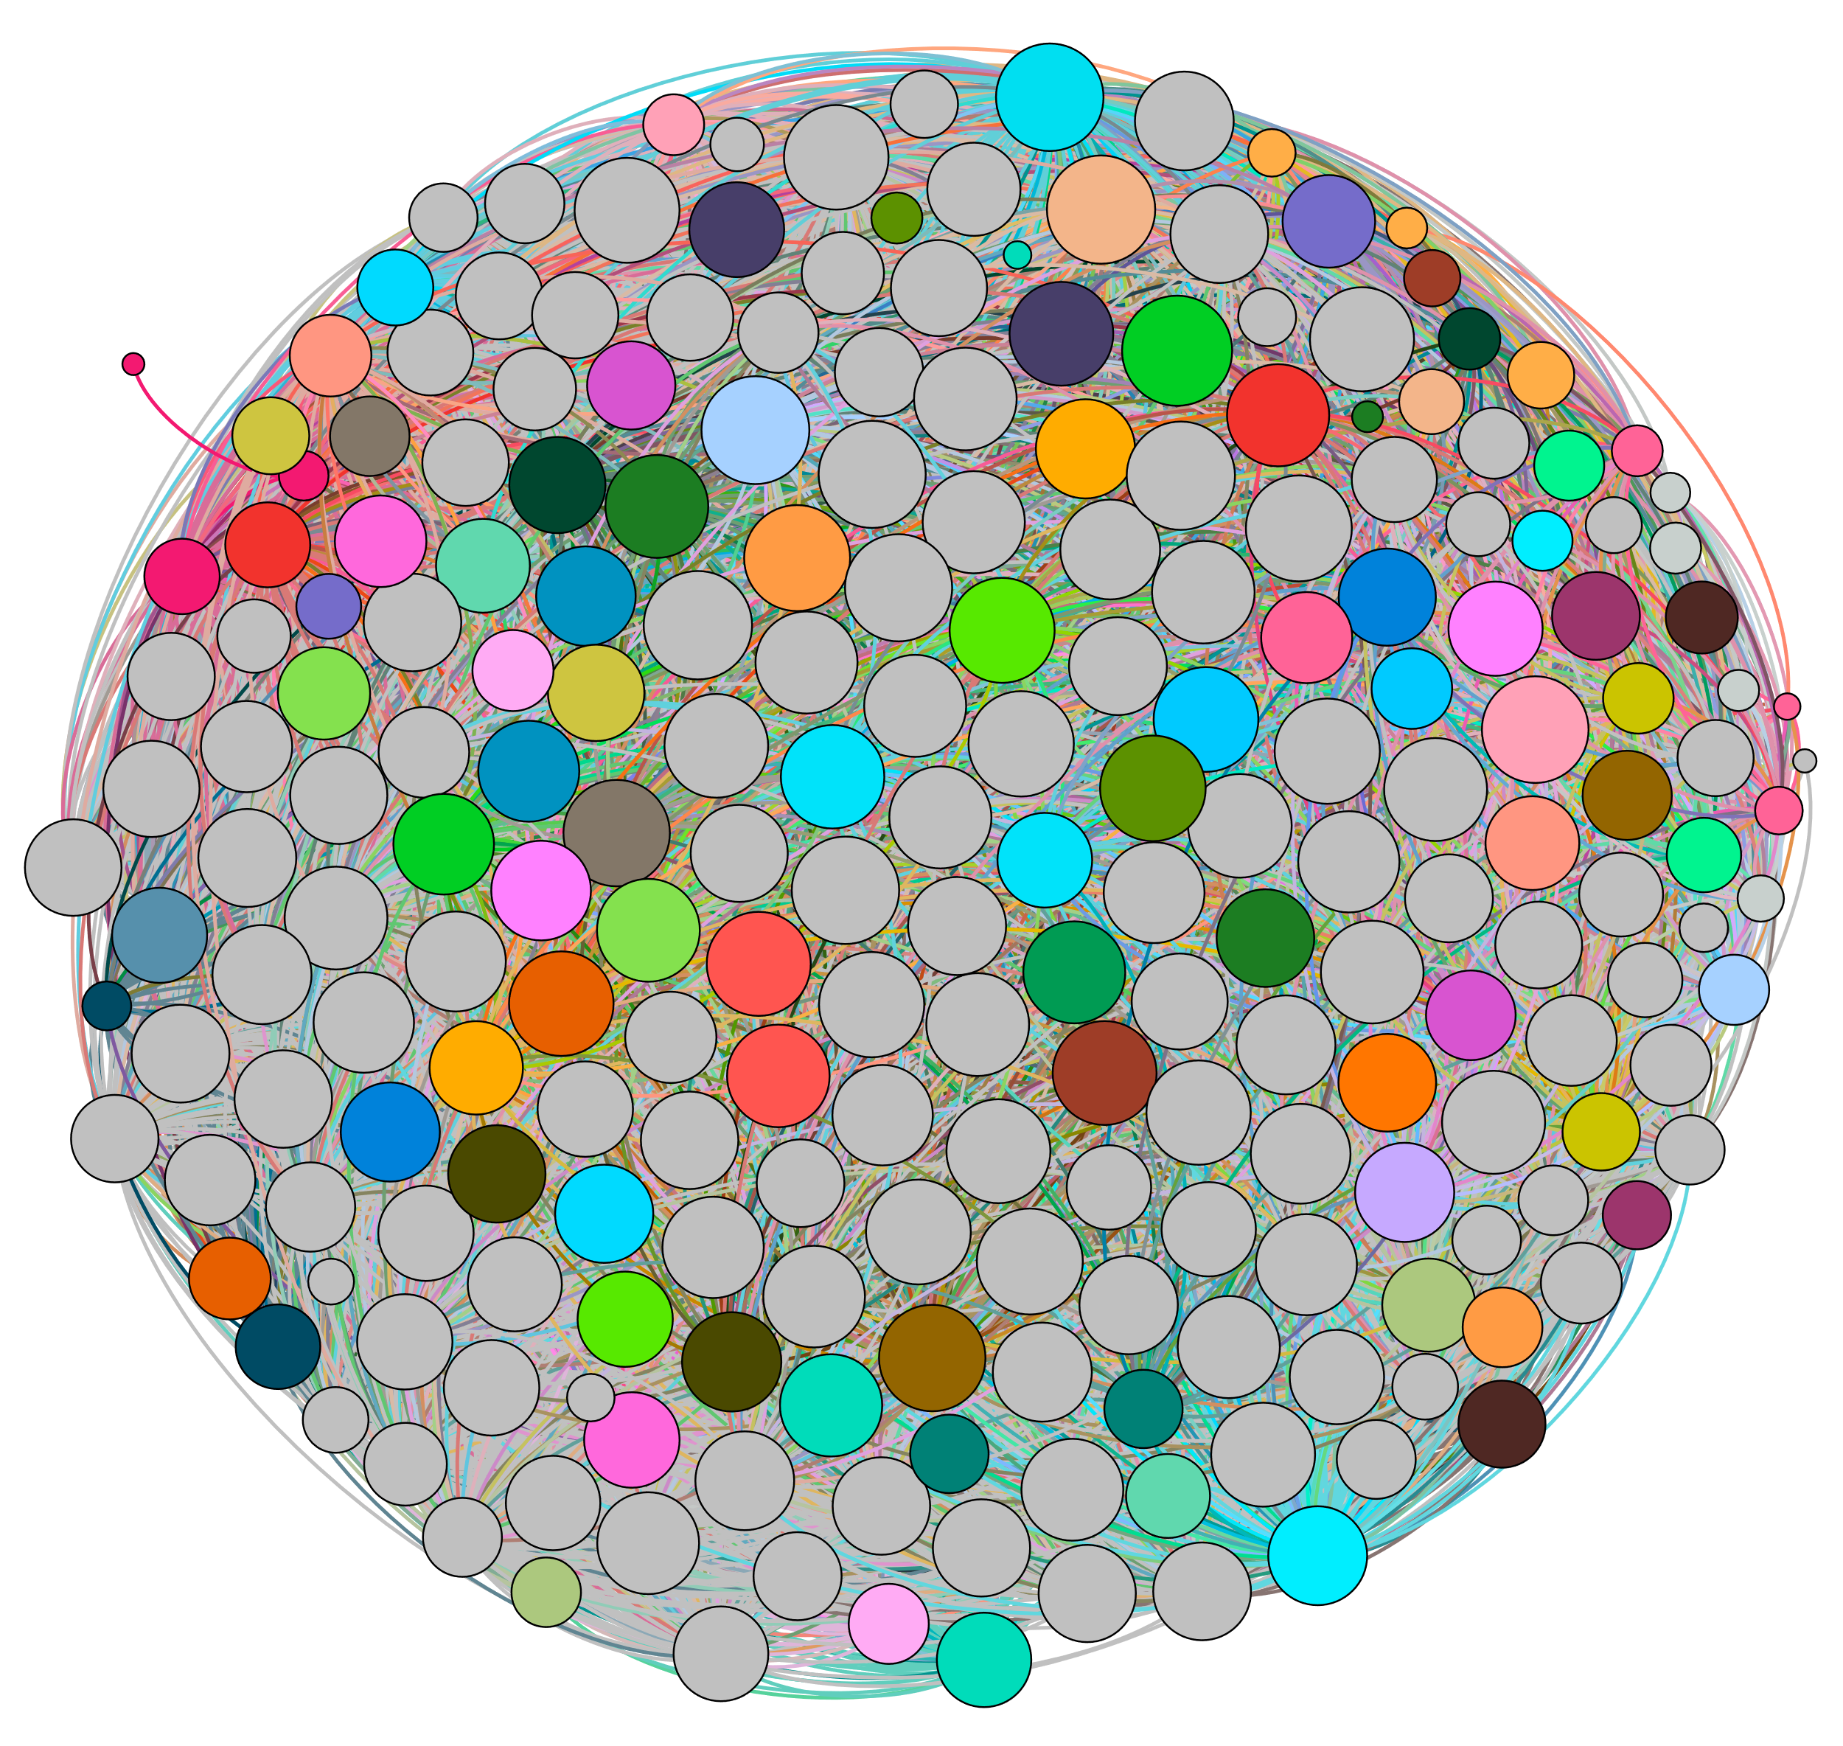

This graphic is the High School Community with Modularity set to 0.1 (More Communities) and the colour palette set to 50. What is clear in this image is the level of interconnectivity within this community and the lack of distinct communities based on the Facebook Network. This community is in stark comparison to the Baseball community.